Customer Experience ̶ Shipped Order

Wonder what customers see when they get your invitation to purchase cookies?


A customer receives a girl’s email announcing that cookie season is open. The customer clicks the “Buy Cookies Online” link and is taken to the girl’s Digital Cookie site.

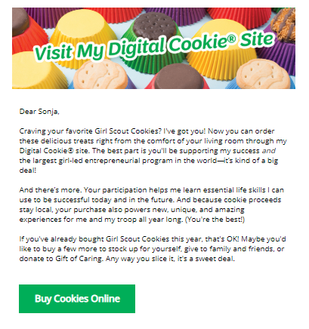


As the customer orders boxes, the total amount updates.
Once the order is completed, the customer selects the delivery method, then clicks the “Checkout” button.

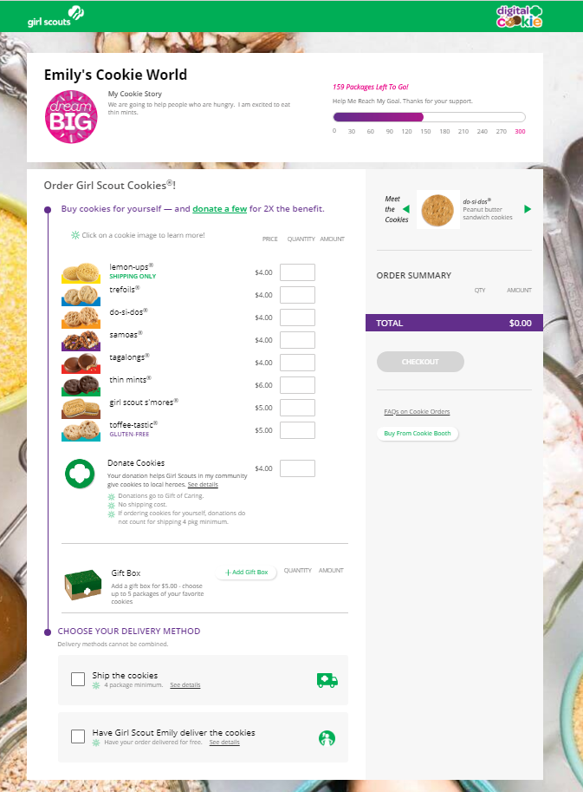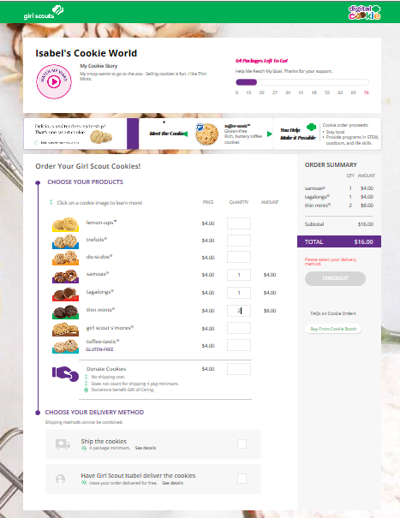
Start checkout

Customer enters box quantity

Start checkout

Checkout

Select Delivery Method


The customer is taken to a “Check Out” screen to complete basic shipping and billing information. Once they complete that, they click the “Continue” button.

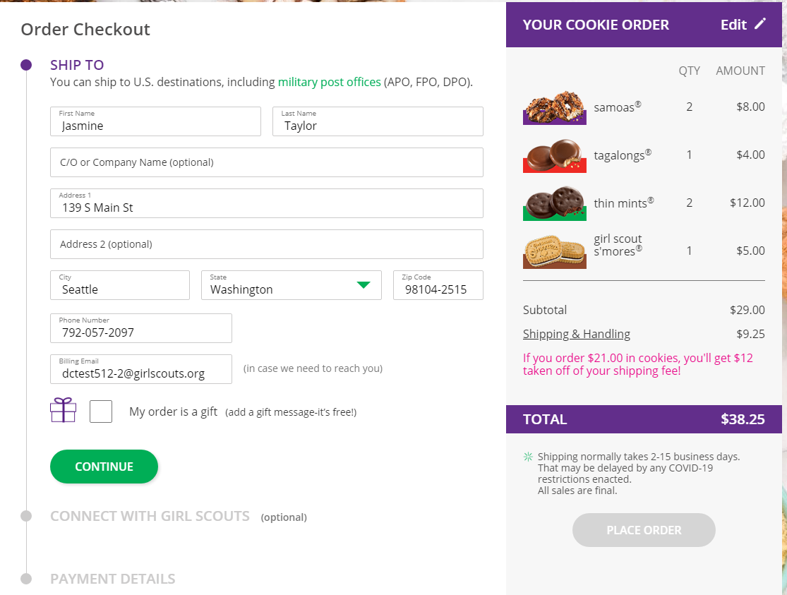



The next screen is optional and asks customers to share if they were Girl Scouts and indicate if they want membership or volunteer information. Then, they enter their payment information and click “Place Order”.

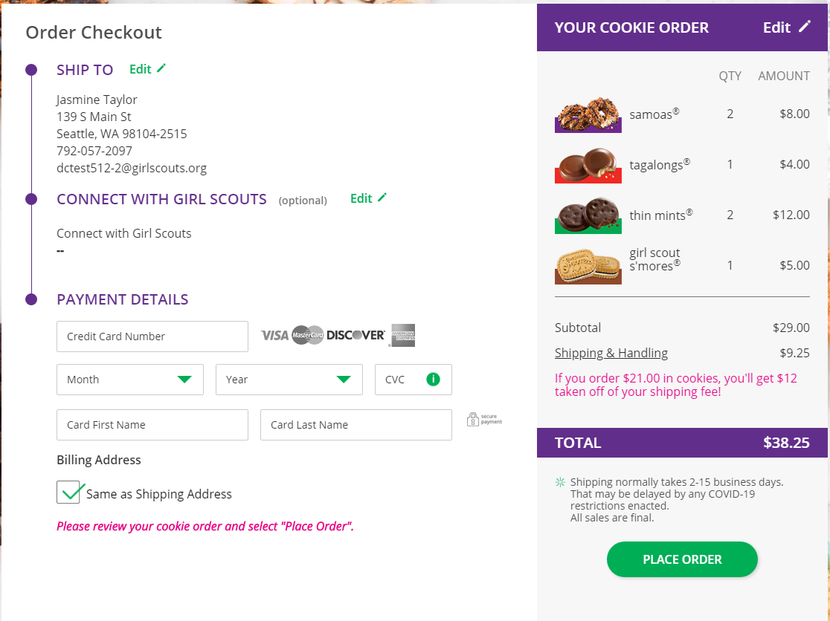


The customer then sees an order confirmation screen that includes the option of placing a new order in case they want to send some to a friend!

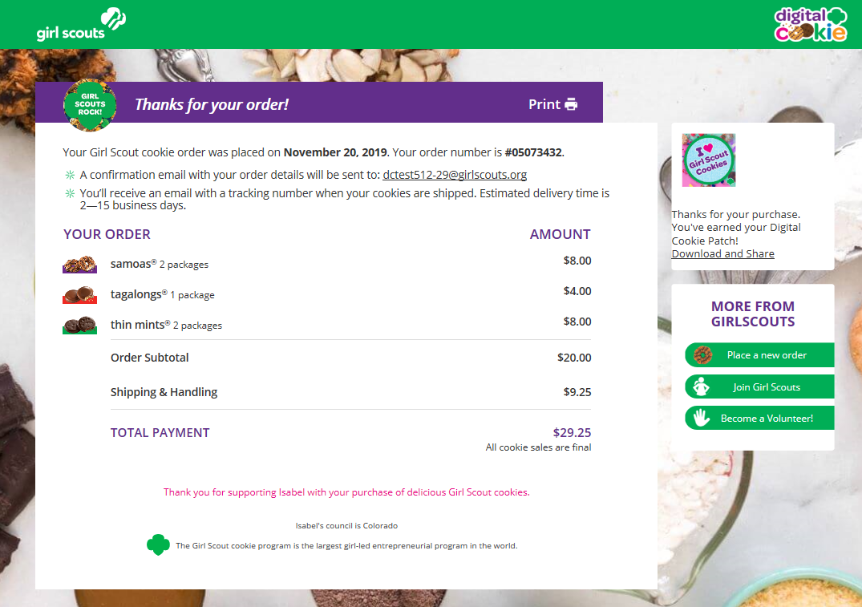


Customers will receive a series of emails about their order.

First they get an order confirmation:

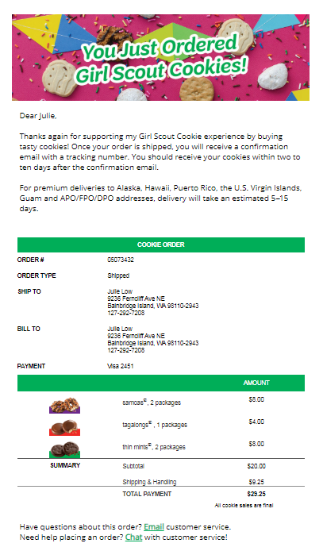

Then they receive an email when the cookies have shipped and are on their way.
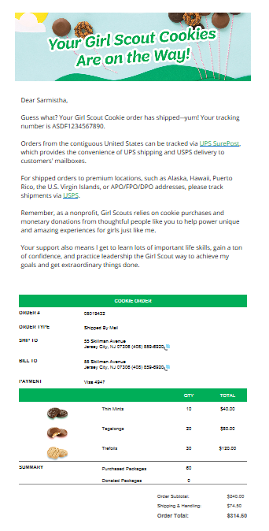

An email thanking the customer for his/her support and asking them to complete a quick survey can be sent by the girl at the end of the sale.
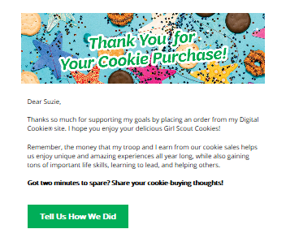

If the order is a donation or contains a donation, the emails will reflect that as well.

Remind your Girl Scout a personal note helps create a satisfied customer who is likely to purchase cookies from her again.

